Name
University affiliation
Date
The Making of the Second Ghetto
The second ghetto was an expansion of the Chicago's Black Belt which took place immediately after the second world war. At that time, there was an increase in the civil rights movements, and Chicago had to deal with the rapid growth of the black population by expanding and enforcing the ghetto. According to Hirsch’s central arguments, the “second ghetto” emerged between 1940 to 1960. It is said that it was created by inertia, it was not a random act that was initiated by the poor black Americans who showed up in Chicago but rather an organized group that had its genuine demands as per their policies and priorities (Bickford & Massey,1991). They were condemning the racist power structure which was out to contain the black people.
In Chicago, the ruling class had an idea of preventing the rapid and outward expansion of the black community, so they came up with a plan that can house and concentrate the black population. The “redevelopment” Meant that the black people could be moved from their valuable property and be stacked into “ second ghetto” which had massive highrise housing projects. By the year 1976, there were already huge complex housing projects that had around 4,000 apartments. The projects were home to 5% of the population of the city, which was mainly the black population (Mohl, 1995). The local ruling and business moguls had built what was referred to as the “second ghetto.”
There were several attacks with over 30 arson bombings, burning, and looting of the buildings that housed the black community. It was a history of violence dedicated to the blacks. Such kind of brutal killings was enforced by the then media which was silenced not to publicize the incidences. Police also took part by allowing racist crowds to harass and terrorize the black community who were found in the wrong neighborhood.
The attacks and confining of the blacks into ghettoized zones was a mechanism that was put in place to enforce segregation. The result of the government policy on decision making by secluding the white and concentrating the blacks in the newly build houses triggered racial transitions and civil rights litigation. It also led to the race relations in Chicago adding to the new dimension of the human rights activists and the civil rights era. This was later on marked by the rise of the blacks such as Martin Luther King, Jr as well as the explosion of the northern cities demanding for their rights and fight against racism.
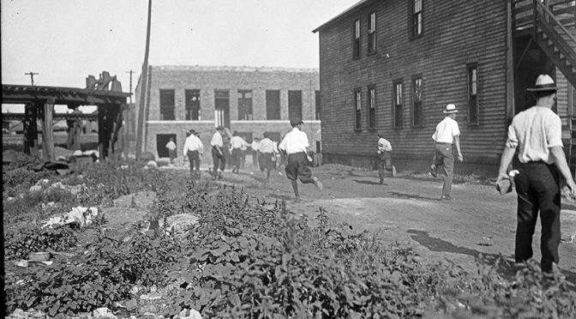
Construction of the “second ghetto”

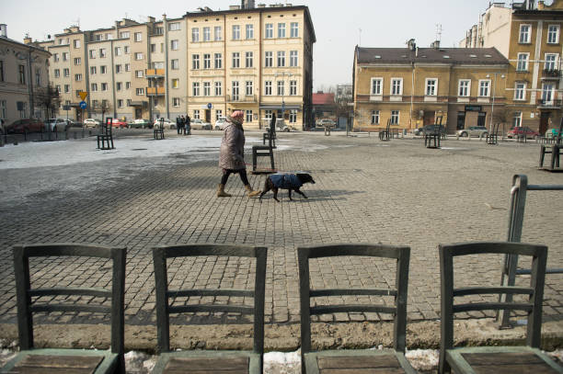
Highrise “ghettos”

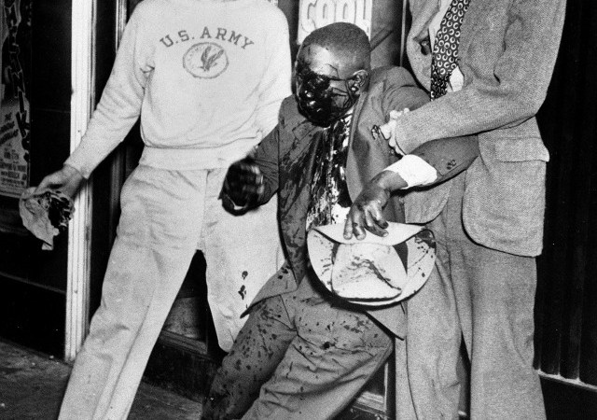
Injustices done on the blacks

References
Bickford, A., & Massey, D. S. (1991). Segregation in the second ghetto: Racial and ethnic segregation in American public housing, 1977. Social Forces, 69(4), 1011-1036.
Mohl, R. A. (1995). Making the second ghetto in metropolitan Miami, 1940-1960. Journal of Urban History, 21(3), 395-427.

